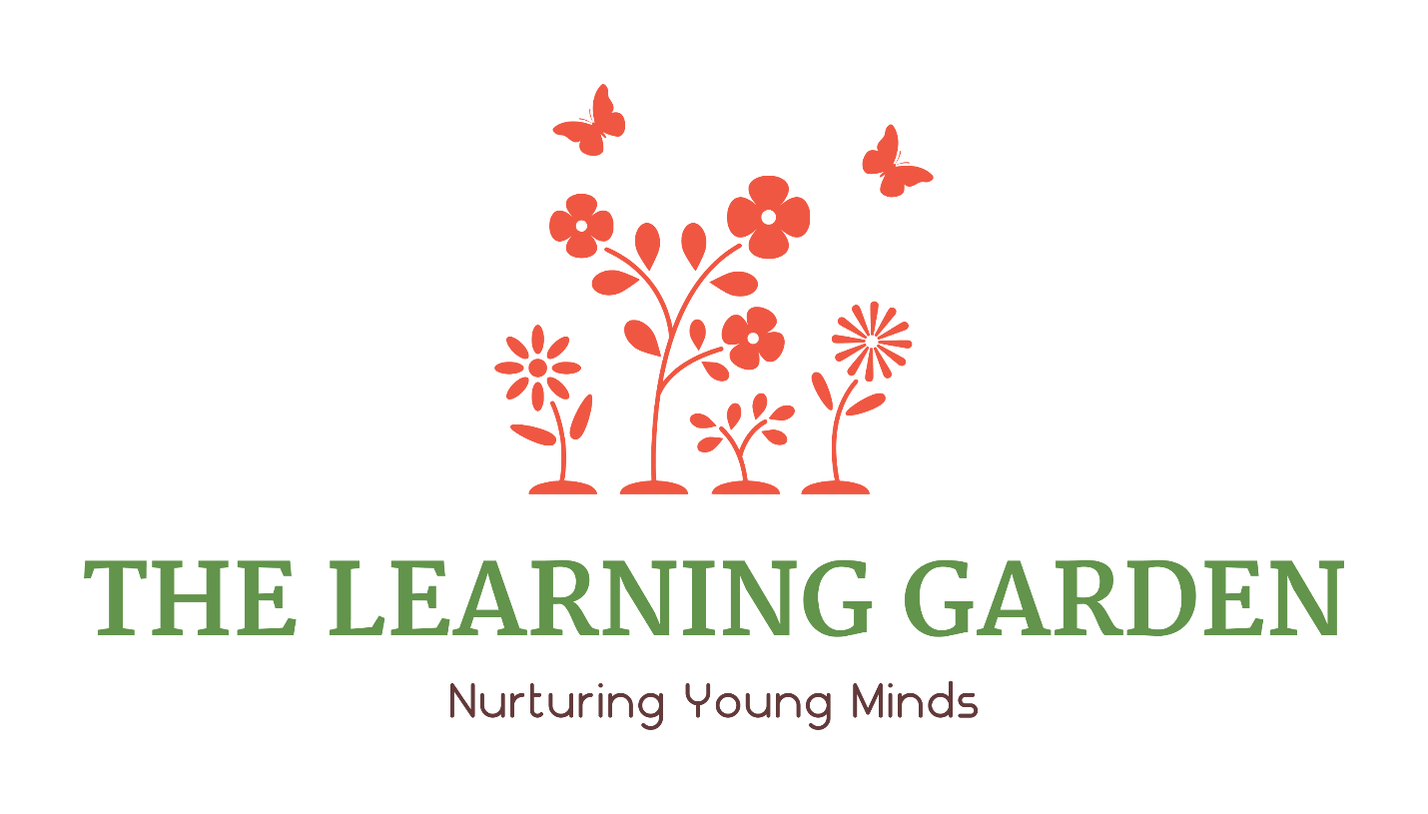
The Leaning Garden at Hamline
1514 Englewood Avenue
St. Paul, MN 55104

Child Care Program Plan

Supervision
Policy
All children will be supervised by sight and sound at all times. When children are in attendance, all staff working with the children should know how many children are under their supervision at all times.
Procedures
Upon arrival to the center parents/guardians will sign their child into the center and teachers will document their presence on the attendance forms. During departure times, parents will sign their children out of the center and teachers will update the attendance form.
Teachers will do a name-to-face count during transitions to or from outside, on field trips, during fire and tornado drills and when taking children to the bathroom. Name-to-face counts will also be done periodically throughout the day and any other time that it is appropriate, such as during arrival and departure times.
Age Categories, Ratios and Group Sizes
Age Categories:
Infant: 6 weeks to 16 months
Toddler: 16 months to 33 months
Preschooler: 33 months but has not yet attended the first day of kindergarten
Ratios and Maximum Group Sizes:
Age/classroom Staff-to-child ratio: Maximum group
size:
Infants 1:4 8
Toddlers 1:7 14
Preschool 1:10 20
Our program assigns specific staff to work with each group of children and strives to keep each child with the same teaching staff for as long as possible, provided that licensing and space allows.
Maximum Licensed Capacity of the Center:
14 toddlers, 46 preschoolers/school age (not to exceed 16 school age = 60 children
Children Served
The Learning Garden at Hamline provides education and childcare services to children without regard to race, creed, religion or economic level. Therefore, any child between the ages of 6 weeks and the start of kindergarten is eligible to apply for enrollment. We also have a before school option for children kindergarten to age 8.
Hours of Operation
Days and Hours of Operation
The Learning Garden at Hamline is open from 6:00 a.m. to 6:00 p.m. Monday through Friday, 12 months a year. We also offer drop-in care and back-up care if space is available.
The Learning Garden is closed on the following holidays and Staff Professional Development Days:
  - Labor Day (September)
  - Columbus Day (October-Staff Professional Development Day)
  - Thanksgiving Day (November)
  - Day after Thanksgiving (November)
  - Christmas Eve (December 24)
  - Christmas Day (December 25)
  - New Year’s Day (January)
  - Staff Professional Development Conference (Held in Jan or Feb annually)
  - Presidents’ Day (February)
  - Forth Friday in April (Staff Professional Development Day)
  - Memorial Day (May)
  - Independence Day (July)
  - Friday before Labor Day (August/September-Staff Professional Development Day)

Education Methods
Mission
The mission of The Learning Garden is to provide quality early childhood care for the surrounding community. Our program is designed to meet the special needs of infant, toddler, and preschool children in a safe and nurturing environment. Our goal is to strengthen the bridge between school and family life by creating a special place that supports them both. We offer families a partnership that provides support and encouragement as well as information about child development.
Educational Philosophy
The Learning Garden believes that parents are a child’s first teachers and that it is our role to provide children with a stimulating, nurturing, educational experience that promotes each child's social/emotional, physical, and cognitive development. Our goal is to support children's desire to be life-long learners as they develop at their own pace so that each child is successful in both school and in life.
Child Care Program Plan Review
Each October the Child Care Program Plan is reviewed in writing and documented by the lead teachers, administrators and coaches to ensure it reflects our annual program evaluation.

Goals and Objectives
Education Goals
The Learning Garden uses a child-centered, play-based approach and has chosen to use Creative Curriculum as its curriculum framework. Our teachers use the following resources when designing and implementing curriculum activities:
- Creative Curriculum by Teaching Strategies
- Early Childhood Indicators of Progress: Minnesota’s Early Learning Standards
- National Association for the Education of Young Children (NAEYC) Position Statement: Developmentally Appropriate Practice in Early Childhood Programs Serving Children from Birth through Age 8
- Funshine, an online curriculum linked to Minnesota’s Early Learning Standards.
- Early Childhood Workshop (St. Paul Schools)
- Program for Infant and Toddler Care (PITC from WestED)
- Second Step (Social Emotional Curriculum)

Goals for each area include:

Social: To help children feel comfortable in school, trust their new environment, make friends, and feel they are a part of the group.

Emotional: To help children experience pride and self- confidence, develop independence and self-control, and have a positive attitude toward life.

Cognitive: To help children become confident learners by letting them try out their own ideas and experience success, and by helping them acquire learning skills such as the ability to solve problems, ask questions, and use words to describe their ideas, observations, and feelings.

Physical: To help children increase their large and small muscle skills and feel confident about what their bodies can do.
Literacy: To help children develop literacy skills in the areas of listening, speaking, emergent reading and emergent writing.

Mathematics: To help children increase their understanding of mathematical concepts such as logical thinking, number concepts and operations, patterns and relationships, spatial relationships/geometry, measurement and mathematical reasoning.

Science and Technology (Scientific Thinking and Problem-Solving): To help children develop their observational, questioning and investigating skills.

Social Studies: To help children become part of their home and school community by helping them to understand human relationships and the world around them.

Creativity and the Arts: To help children be creative thinkers by allowing opportunities for creative expression and for responding to and evaluating creative elements.

Approaches to Learning: To provide opportunities for children to express their curiosity, take risks, use their imagination, invent and to increase their skills in the areas of persistence, reflection and interpretation.

Child Progress and Parent-Teacher Conferences
Policy
Teachers will assess the children using work samples, observational notes, photos and parent interviews. This information will be used to share children’s progress with parents three times per year during conferences or home visits. Parents will be included in the assessment process and are encouraged to share their observations with teachers.

Procedures
Teachers will record their observations in each child’s portfolio. Other items to be included in the portfolio include artwork, writing samples, and photos. Teachers will collect information from parents through conversations, emails, KidsReports and the Preconference forms.
Teachers will complete an assessment form at the end of each reporting period for each child. At each conference or home visit the teachers will share each child’s portfolio, assessment and conference form with the parents. Parents and teachers will discuss the child’s progress and determine goals for the next period. Parents and teachers will sign the conference form, parents will receive a copy of the conference form and a copy will be kept in the child’s file.
Daily Schedules
Policy
Each teacher will create a daily schedule that is appropriate for the ages and development of the children enrolled. The daily schedule will provide for a balance of child-initiated and adult-directed activities, including individual and small group activities, routines and transitions. The daily schedule will allow time for the following activities:
- Infant Feeding and/or Family Style Meals (breakfast, lunch and snack)
- Hand washing
- Toileting, diaper changing or potty training
- Large Group Activities
- Small Group Activities
- Free Choice Play
- Gross Motor Activities (indoor and/or outdoor)
- Quiet/Rest Time
- Arrival and Departure rituals
- Story time
Other Daily Schedule Guidelines:
- Child-initiated activities must be provided for the majority of the child’s day
- 30 minutes must be allowed for breakfast and lunch and 15 minutes for snack
- Quiet/Rest time may not exceed 2 ½ hours (see naptime policy)
- Activities may be adjusted or changed according to the needs of the children or to cope with severe weather or other situations that may arise
- There must be clear unregimented transitions between activities and children must be given warning to all transitions in the schedule.
- Children should not be required to move as a group from one activity to another unless they are transitioning to outdoors, another location in the building, for a fire or tornado drill or on a field trip.
- 30 minutes of outdoor large muscle activity must be provided daily (weather permitting)
- Self-help and social skills must be incorporated into the daily routine such as cleaning up own spill, toileting, and putting materials away.
Procedures
Each teacher will create a schedule for their classroom allowing for the required activities using the policy guidelines. The schedule will be posted on the parent board. A picture schedule will be posted at eye level in the toddler and preschool classrooms to assist children in understanding what activity is to come next.
Materials
Furnishings, equipment, materials and supplies
The Learning Garden ensures that each classroom has the quantity and type of furnishings, equipment and materials specified for the infants, toddlers, and preschoolers that they serve.
The Learning Garden rotates materials between all classrooms at all locations depending on the interest and development of the children. Materials that rotate include:
- Blocks, cars and animals
- Musical instruments and CD’s
- Science materials
- Dolls and dramatic play materials
- Books
- Puzzles and games
- Infant and toddler toys (push toys, rattles, pop up, etc.)
- Indoor/Outdoor Large Muscle equipment
- Art and craft materials
Activities & Interest Areas
The Learning Garden provides opportunities for children to engage in developmentally appropriate activities by organizing the classrooms into learning opportunities based on the children’s development, culture, interests and abilities. The teachers develop individual and group lesson plans that include teacher-directed, child-directed, quiet and active activities.
The Learning Areas and the possible activities include:
Books/Library: There is an area in the classroom that contains a variety of books that are neatly displayed with covers visible to the children. The area includes a variety of books such as non-fiction, fairy tales, wordless, and books with familiar plots and colorful illustrations. Books reflect the current study topic(s) and reflect the cultures and backgrounds of the children in the class. Books are available to children throughout the day and books are displayed throughout the classroom in all the areas. Opportunities for reading include quiet reading and read-alouds in small or large groups or with individual children.
Blocks and Building: This area contains a variety of materials that will allow children to explore and learn spatial and mathematical concepts, as well as allow for engaging in pretend play. The materials in this area include blocks and building materials, and may include wooden or foam blocks, unit blocks, people, cars, traffic signs, animals, ramps, and garages.
Science and Exploration: This area contains materials that allow children to explore investigate and experiment such as measuring devices, magnets, magnifying glasses, and collections of materials found in nature such as shells, pinecones and rocks.
Math and Manipulatives: This area contains materials that allow children to develop number, color, spacial and problem-solving skills such as puzzles, matching games, counting bears, Legos, patterning cards, lacing beads and geometric shapes.
Dramatic Play: This area contains materials that allow children to learn about the world by allowing opportunities to act out the roles of others. Materials in this area may include dishes, dolls, mailbox, dress-up clothing, and child sized furnishings.
Art/Easel: This area contains materials that allow children to express themselves creatively. An easel is available in this area as well materials such as paints, crayons, markers, glue, a variety of paper, and collage materials.
Writing: This area contains materials to engage children in emergent reading and writing. Materials may include pencils, stencils, paper, journals, word cards and alphabet letters.
Sensory: This area contains materials that allow for children to explore materials with their hands and engages their senses. Materials in this area may include sand, water, play-dough, finger paint and glurch.
Large Group: This area allows the children to come together in a large group to promote a sense of community. Activities in this area include group stories or flannel board stories, music and movement activities, class meetings, shared stories or games.
Music and Movement: This area allows children to appreciate music and express themselves through music. Materials in this area may include a CD player, musical instruments, scarves and bean bags.
Quiet Area/Private Spaces: These areas allow children to seek out private,quiet space, or to play with one or two other children. These areas may be located in several places in the classroom, could be partially enclosed, be a small table or contain soft elements such as large pillows or child sized furniture.
Child Care Program Plan Available to Parents
Parents/Guardians may review our Child Care Program Plan at any time. A copy of our plan is available on our website, www.thelearninggarden.us and on site in our Welcome area.

